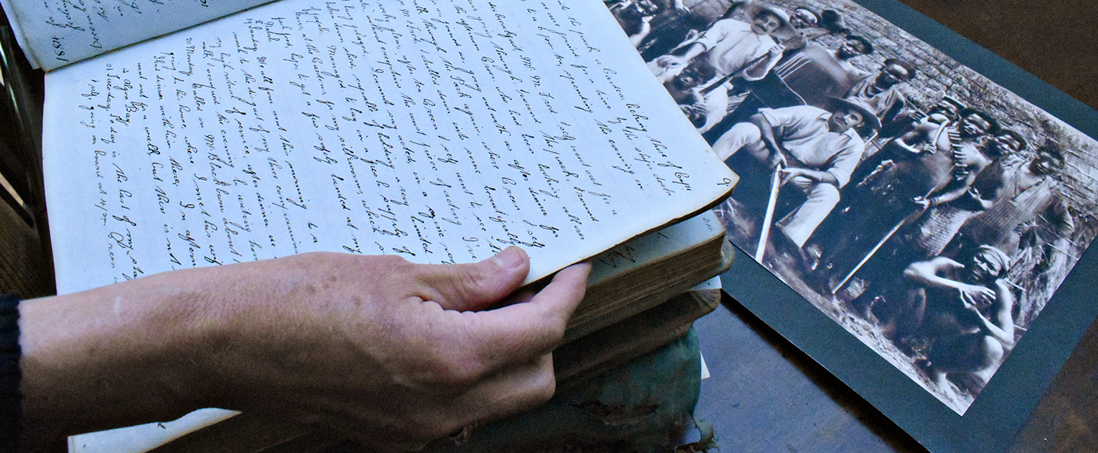
Digging the Family Dirt
Engaging, reconciling, and creating with your family history
Antonia Banyard | www.antoniabanyard.ca

Getting started
There are SO MANY resources to help you on your family research journey! Here are just a few.

Ask your local library if they have any family research resources. Many libraries have accounts with Ancestry.ca, saving you the membership fee. Some libraries also offer workshops on various aspects of family research.

The BC Genealogical Society offers workshops, research assistance, online resources, links to more resources and a library.

American-Canadian Genealogical Society has information on New England, Northern and Hudson River Valley NY, Quebec, Maritimes and Acadian history

Society of Genealogists based in the U.K.

Building your family tree, and beyond
There are a number of genealogical websites that can help you to find basic family information. SO MANY records have been digitized. Some of these websites are free, some require paid memberships (for the extras!).

Ancestry.ca
FamilySearch.org
FindMyPast.com
National Archives (US)

Organizing your family photos
Opinions vary on the best way to sort and organize family photos. Here are a couple to browse:
“The Best Way to Organize Old Family Photos” by photographer Abby Murphy
“Organize Old Family Photos…” by Denise May Levenick
“8 Steps to Organize and Preserve Your Family Photo Prints” by Maureen A. Taylor

I like to read at least three different articles on a subject, until they start to contradict each other, and then pick and choose what I think will work for me. You may also want to hire a professional photo organizer, especially if your task is daunting.

You could also try breaking up the task into smaller parts. Or invite someone to tackle it with you. Or find ways to make it fun (put on music?).

When copying photos
• Scan at high resolution (300–600dpi) to get as much detail as possible. Aim to scan as close to a 1st generation image as possible. (A negative is 1st generation, a print is 2nd, a photo copy of the print is 3rd, etc.)
• Establish a file naming convention to make future searching easier.
• Record writing around photos (somewhere you will remember!). These notes may be useful clues later on.
• Back up your files in at least two other places

When sorting originals
• You may want to remove prints from albums.
• Establish a sorting system. Again, to make future searching easier. Some people recommend storing images in the same order as the original album, as the order itself tells a story. Others recommend sorting photos by era, decade, family group, or by occasion.
• Record writing around photos. Again, these may be useful clues.
• You may want to pick a few select photos to display.
• Store the rest in archival boxes or photo sleeves.

External historical photo archives
You may want to add non-family photos to add historical context, or simply more visuals, to your family’s story.

Library and Archives Canada online catalogue has photos, documents, government records, etc. Some have been digitized and are free to download, some must be ordered, for a fee. (Allow at least 6 weeks for ordering.)

The American Library of Congress Online Catalog. Thousands of photos (but not all) have been digitized. If you want to reproduce images or publish them in any way, you need to check that they are free to use and there are no restrictions to their use (under “Rights Advisory”).

Wikipedia articles sometimes have images that are free to use. But only use ones without copyright restrictions. But be sure to read the copyright or licensing information before you share. Public domain is the safest bet. You can use it for personal or commercial use.
There are many variations of “Creative Commons” licenses:
With attribution – free to use, but credit the creator
Share alike – free to use, but only if your work will also be shared freely
Non-commercial – free to use, but only if your work is distributed for free
And then there are combinations of these. Copyright is complicated. If I’m ever unsure, I err on the side of caution and look for something else.

Printing your family history
There’s nothing wrong with the good ol’ photocopier. If you need or want something more, you can look into digital and on-demand printers. Here are just three suggestions:
Locally: Hall Printing design, printing, and binding services
Victoria: Printorium Bookworks offers editing, design, and printing services
Manitoba: FriesenPress, an offset printer that also offers self-publishing services
and history book guide

A bit of further reading
“…family research establishes, creates, and recreates connections with others, both the living and the dead.”
“Who We Are, and Why We Do It” Researcher and history professor Emma Shaw looks at why people (Australians, in her case) study their family history.

“20 Reasons Why You Should Write Your Family History” by the New York Public Library.

Critical Family History
If you’re interested in digging a little deeper and adding context to your family story, I recommend Christine Sleeter’s webpage on Critical Family History.

If you don’t mind working through a little academic-speak, you can download the special issue of the periodical, Geneology, “Geneology and Critical Family History”. (Scroll down to the “Download all Papers” button.)
And if you’re not keen on academic-speak, you can always just skim the abstracts.

Be skeptical! Be open! Have fun with it!

